GALATIANS
God's grace brings freedom
WRITTEN

48 AD
KEY VERSE
"It is for freedom that Christ has set us free. Stand firm, then, and do not let yourselves be burdened again by a yoke of slavery."
5:1

Last updated April 2, 2023

PURPOSE
Explain that the Christian life comes from the Spirit and not the Law of Moses.
CONTENTS

INTRODUCTION 2
WHAT IS A CHRISTIAN? 2
BACKGROUND 3
STRUCTURE 3
OPENING (1:6-9) 3
PROPOSITION/THESIS (2:15-21) 5
JUSTIFICATION: 5
ARGUMENTATION (3:1 - 6:10) 6
OVERVIEW OF CHAPTERS 3-4 6
ARGUMENT FROM EXPERIENCE (3:1-5) 6
ARGUMENT FROM THE OLD TESTAMENT (3:6-14) 6
EXAMPLE 1: A COVENANT/WILL (3:15-29) 7
KEY VERSE AND CLIMAX (5:1-4) 8
5:16-25 8
THE WORKS OF THE FLESH VS. THE FRUIT OF THE SPIRIT (5:16-25) 9
APPLICATION 9
WALKING IN THE SPIRIT IS: 9
SO WHAT IS A CHRISTIAN? 9

INTRODUCTION
A subtitle for Galatians could be: "What is the true gospel?" The congregations in Galatia had been visited by some false teachers who preached Jesus and the Law of Moses. They believed that Gentile Christians had to be circumcised and keep the Law of Moses to be Christians. Paul strongly opposes this and emphasizes that Christians are saved by faith alone, without the law, and he says they must hold fast to the freedom they have in Christ.
Paul uses the word "justify" several times - an expression from the courtroom that was used when a defendant was acquitted and declared innocent. He insists that they are declared innocent in God's eyes only because they believe and not because they follow the Law of Moses.
It can be difficult to know what to do with the Law of Moses now that Jesus has come. In any case, Paul makes it clear that to follow it is to go backward in God's plan. The Law of Moses was time-bound, and Christians were never meant to live according to it. We are called to freedom in Christ and must not become slaves again (5:1).
Galatians may have been written around the year 48 AD. If so, it is Paul's first letter.

WHAT IS A CHRISTIAN?
- A good person?
- Someone who believes in God?
- Someone who reads the Bible?
- Someone who goes to church?
- Someone who talks about Jesus?

"Galatians is all about the gospel – the gospel all of us need throughout all of our lives. It's dynamite, and I pray that its powerful message explodes in your heart as you read this book." Tim Keller
"The gospel is not only the way to enter the kingdom; it is the way to live in the kingdom."
"The letter to the Galatians is my own letter. I have betrothed myself to it. It is my wife." Martin Luther

BACKGROUND
Some Gauls migrated all the way to Asia Minor (278 BC) to become mercenaries. This gave name to the Roman province Galatia. They were known as strong warriors and as “savages” because of their looks.
The Judaizers preached Jesus and The Law of Moses. They claimed that gentile Christians had to be circumcised and keep the Law of Moses in order to belong to God’s people.

STRUCTURE
1:1-5 Introduction
1:6-9 Opening
1:10 - 2:14 Case presentation
There is only one gospel, which both he and the other apostles preach. The “gospel” of the Judaizers is not the gospel of Christ.
2:15-21 Proposition/thesis What is the role of the law of Moses for a Christian?
3:1 - 6:10 Argumentation
Even Abraham, who lived long before the law of Moses, was saved by faith and not by works. The law was only in effect until Jesus came. Christ has set us free to a life in the Spirit.
6:11-17 Ending
6:18 Letter outro

OPENING (1:6-9)
"I am astonished that you are so quickly deserting the one who called you to live in the grace of Christ and are turning to a different gospel, which is really no gospel at all. Evidently some people are throwing you into confusion and are trying to pervert the gospel of Christ. But even if we or an angel from heaven should preach a gospel other than the one we preached to you, let them be under God's curse! As we have already said, so now I say again: If anybody is preaching to you a gospel other than what you accepted, let them be under God's curse!"
- They are turning away from God and His grace
- Any change in the gospel →→ not the gospel at all
- No one, not even Paul himself, can present a new gospel
- Main theme: “What is the true gospel?”

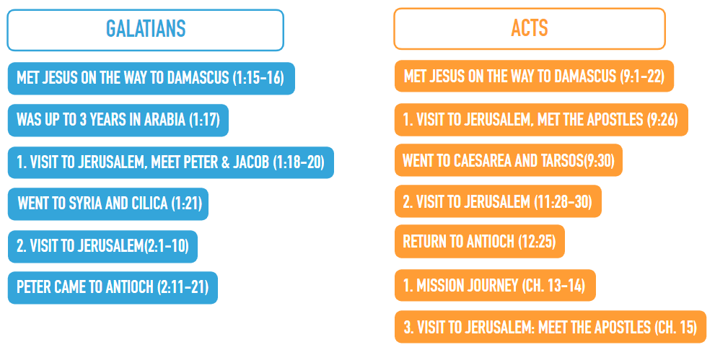

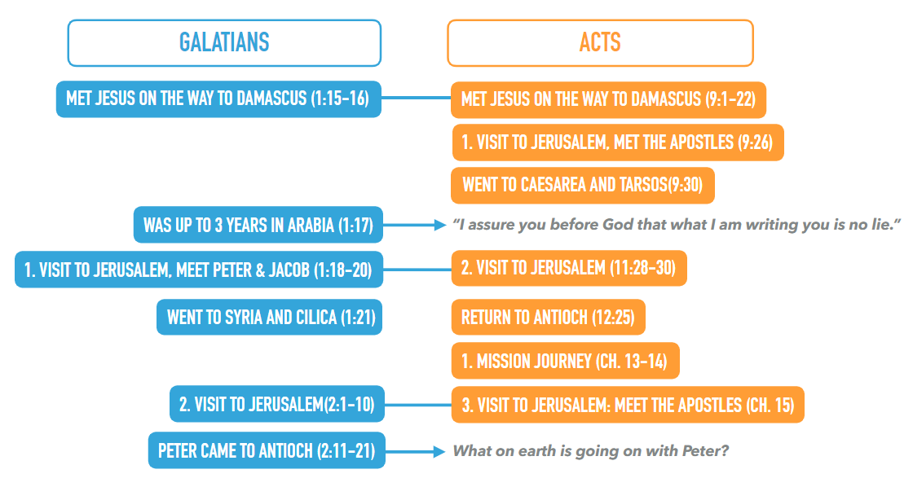

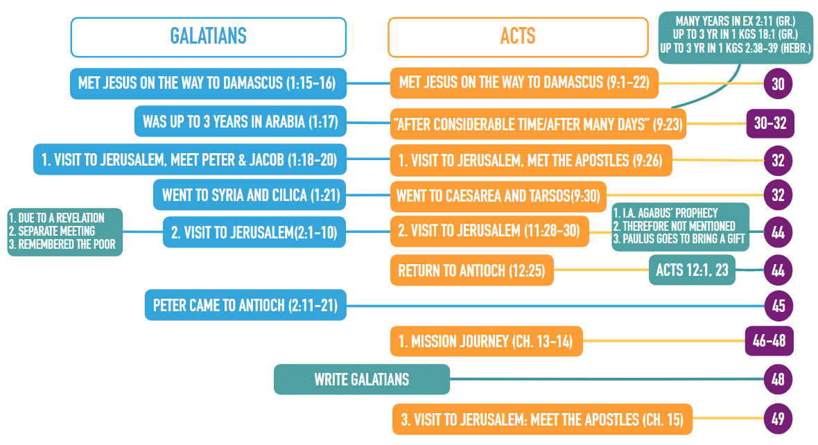

PROPOSITION/THESIS (2:15-21)
"We who are Jews by birth and not sinful Gentiles 16 know that a person is not justified by the works of the law, but by faith in Jesus Christ. So we, too, have put our faith in Christ Jesus that we may be justified by faith in Christ and not by the works of the law, because by the works of the law no one will be justified." Gal. 2:15-16
- Several keywords are introduced: justify, law, works, faith, righteousness…
- Case: What is the role of the law of Moses for a Christian?
- Specifically: Should the Galatians be circumcised?

JUSTIFICATION:
A judicial expression. A public proclamation by a judge that a person is declared innocent and not guilty.

ARGUMENTATION (3:1 - 6:10)

OVERVIEW OF CHAPTERS 3-4
3:1-5: Argument from experience. God gave them the Spirit and does miracles because they believe in Jesus (= “in the Spirit”), not because they follow the law (= “in the flesh”).
3:6-14: Argument from the Old Testament. Even Abraham was declared righteous by faith, long before the law was given.
3:15-29: Example 1: A covenant/will. The covenant with Abraham can’t be changed. God has not changed His way of saving people. It was never through the law, always by faith.
4:1-20: Example 2: Adoption. They used to be slaves under the law and false gods, but now they are God’s children.
4:21-31: A metaphorical point from the Old Testament. Summing up: Kick the Judaizers out of the church!

ARGUMENT FROM EXPERIENCE (3:1-5)
“You foolish Galatians! Who has bewitched you? Before your very eyes Jesus Christ was clearly portrayed as crucified. I would like to learn just one thing from you: Did you receive the Spirit by the works of the law, or by believing what you heard? Are you so foolish? After beginning by means of the Spirit, are you now trying to finish by means of the flesh? Have you experienced so much in vain—if it really was in vain? So again I ask, does God give you his Spirit and work miracles among you by the works of the law, or by your believing what you heard?”

ARGUMENT FROM THE OLD TESTAMENT (3:6-14)
3:6-7: “So also Abraham "believed God, and it was credited to him as righteousness." Understand, then, that those who have faith are children of Abraham.”
3:6-7 →→ Genesis 15:6
- “He took him outside and said, "Look up at the sky and count the stars-- if indeed you can count them." Then he said to him, "So shall your offspring be." Abram believed the LORD, and he credited it to him as righteousness.” Gen. 15:5-6
- Abraham believed and trusted God even though it looked hopeless, and he received promises and righteousness before circumcision.
- Believing that God exists doesn’t save you. You have to have faith in God = trust that His promise will save you.
- “he credited it to him” = an accounting term: “to credit to someone’s account”
- Everyone who is justified by faith is Abraham’s child.
3:8-9: “Scripture foresaw that God would justify the Gentiles by faith, and announced the gospel in advance to Abraham: "All nations will be blessed through you." So those who rely on faith are blessed along with Abraham, the man of faith.”
3:8-9 → Genesis 12:3
“The LORD had said to Abram, "Go from your country, your people and your father's household to the land I will show you. "I will make you into a great nation, and I will bless you; I will make your name great, and you will be a blessing. I will bless those who bless you, and whoever curses you I will curse; and all peoples on earth will be blessed through you.”" Gen 12:1-3
"blessed through you": Salvation by faith to all who believe in Jesus

EXAMPLE 1: A COVENANT/WILL (3:15-29)
3:19-26: “Why, then, was the law given at all? It was added because of transgressions until the Seed to whom the promise referred had come… Before the coming of this faith, we were held in custody under the law, locked up until the faith that was to come would be revealed. So the law was our guardian until Christ came that we might be justified by faith. Now that this faith has come, we are no longer under a guardian. So in Christ Jesus you are all children of God through faith…”
The promise: Justification by faith was given to Abraham (Gen 12:3, 15:6). From Moses to Christ, the people of God were in custody under the law (a temporary addition). Christ is "the Seed" that saves us and makes us children of God through faith. Salvation has always been by faith, like with Abraham, and never by the law. It is not true, as some claim, that:
- “The promise is only for the Jews.”
- “Jesus didn’t deal with our sins.”
- “Jesus doesn’t set us free.”
- “Jesus didn’t fulfill the promises.”
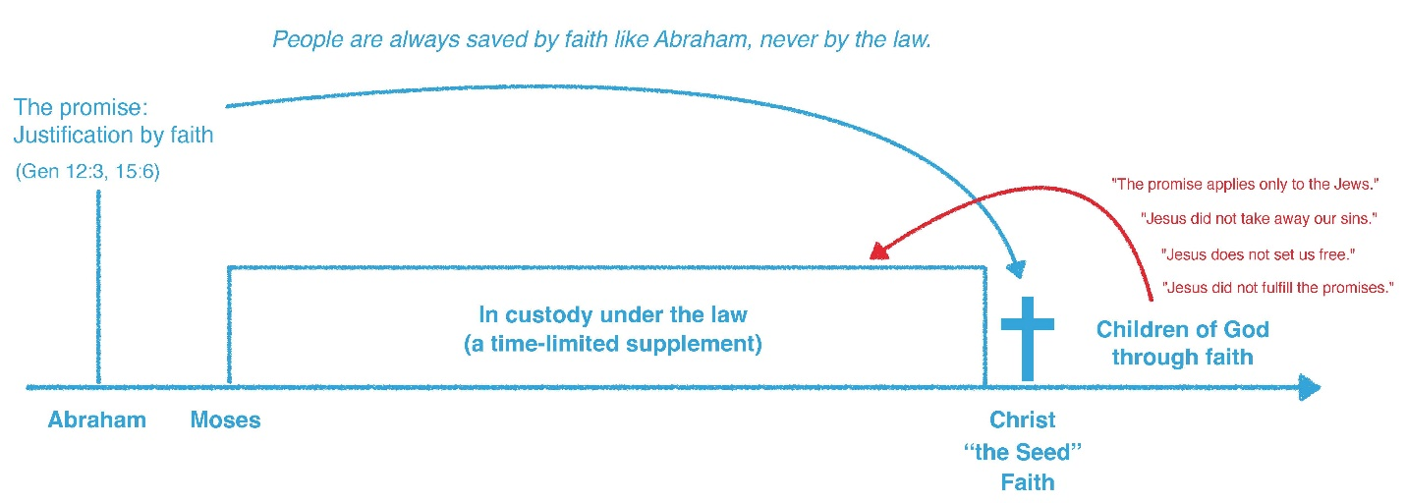

KEY VERSE AND CLIMAX (5:1-4)
“It is for freedom that Christ has set us free. Stand firm, then, and do not let yourselves be burdened again by a yoke of slavery. Mark my words! I, Paul, tell you that if you let yourselves be circumcised, Christ will be of no value to you at all. Again I declare to every man who lets himself be circumcised that he is obligated to obey the whole law. You who are trying to be justified by the law have been alienated from Christ; you have fallen away from grace.”
Paul tells them that if they let themselves be circumcised, they have to keep the whole law. They fall under God’s grace if they have faith. If they trust in their works, they fall away from grace.

5:16-25
“So I say, walk by the Spirit, and you will not gratify the desires of the flesh. For the flesh desires what is contrary to the Spirit, and the Spirit what is contrary to the flesh. They are in conflict with each other, so that you are not to do whatever you want. But if you are led by the Spirit, you are not under the law. The acts of the flesh are obvious: sexual immorality, impurity and debauchery; idolatry and witchcraft; hatred, discord, jealousy, fits of rage, selfish ambition, dissensions, factions and envy; drunkenness, orgies, and the like. I warn you, as I did before, that those who live like this will not inherit the kingdom of God. But the fruit of the Spirit is love, joy, peace, forbearance, kindness, goodness, faithfulness, gentleness and self-control. Against such things there is no law. Those who belong to Christ Jesus have crucified the flesh with its passions and desires. Since we live by the Spirit, let us keep in step with the Spirit.”

THE WORKS OF THE FLESH VS. THE FRUIT OF THE SPIRIT (5:16-25)
1. Walk by the Spirit (v. 16) →→ the only commandment in this passage
2. Be led by the Spirit (v. 18)
v. 22: The Spirit does not produce works but fruit (= character traits)
- The works come as a result of the fruit
3. Keep in step with/follow the Spirit
- “keep in step”: of soldiers who are standing/walking in a row or line

APPLICATION

WALKING IN THE SPIRIT IS:
- Letting Jesus be formed in us (4:19), to become more like Him by following His example and teaching with the help of His Spirit, who God has sent into our hearts (4:6)
- Having “crucified” the flesh with its passions and desires because we belong to Him (5:24), after having Him clearly portrayed as crucified before our very eyes (3:1), we stop the sin on a “motivational level” rather than on a “behavioral level”.
- Still receiving instructions. Paul wrote letters because it was necessary, even though they had the Spirit.

SO WHAT IS A CHRISTIAN?
It is not defined by being:
- A good person?
- Someone who believes God exists? Someone who reads the Bible?
- Someone who goes to church?
- Someone who talks about Jesus?
It is defined as:
- Someone who trusts that what Jesus did on the cross is enough for salvation.
The Christian faith is so simple! You’re saved by faith, then you walk by the Spirit. God does it all. You can never repay Him for this great gift. The only right response is just to be grateful and happy and love Him.

