EXODUS
God delivers Israel to make them his people
SETTING
Israel in Egypt and the Exodus (ca. 1650 BC to 1445 BC)
KEY VERSE
"You yourselves have seen what I did to Egypt, and how I carried you on eagles’ wings and brought you to myself. Now if you obey me fully and keep my covenant, then out of all nations you will be my treasured possession. Although the whole earth is mine, you will be for me a kingdom of priests and a holy nation.’ These are the words you are to speak to the Israelites."
19:4-6

Last updated February 7, 2023

CONTENTS

INTRODUCTION 3
WHY HAS NOT A SINGLE TRACE BEEN FOUND OF THE ISRAEL PEOPLE IN THE DESERT? 4
WHY IS THE EXIT NOT MENTIONED IN A SINGLE EGYPTIAN SOURCE? 4
SOME CONCLUSIONS: 7
JESUS IN EXODUS 8
STRUCTURE 8
CHAPTER 1-2 9
PRIORITIES 9
OMISSIONS 9
ANTHROPOMORPHISMS (“humanizations”) 9
"I AM" (3:14) 10
"YAHWEH" (6:3) 10
4:24-26 PROBLEMS: 11
5:22-23 13
THE HARDENING OF PHARAOH 13
THE 10 PLAGUES 14
PASSOVER 16
12:37: 600,000? ('ELEPH': THOUSAND, TROOP, LEADER, UNIT, FAMILY/GENEALOGY) 17
THE PEOPLE COMPLAIN THREE TIMES (15:22-17:7) 17
"THE ROCK WAS CHRIST" (1 COR 10:4) 18
CHAPTER 19: GOD REVEALS HIMSELF ON MOUNT SINAI 18
THE TEN COMMANDMENTS (20:1-17) 19
SLAVES (21:1-11) 20
CHAPTERS 32-34: INTERRUPTION AND CRISIS 22
CAN GOD REPENT? (32:14) 22
“HOLY TO THE LORD” 26
THE MEETING TENT AND CREATION SYMBOLISM 26
40:34-38 28
GOD'S GLORY AND DWELLING 28
WHAT DOES THE BOOK OF EXODUS MEAN TO US? 29

INTRODUCTION
In English, the book is called "Exodus", which means "exit". In Hebrew, it is called "The names" because it begins with "These are the names..." and lists those who came to Egypt. The exodus from Egypt is the event from the Pentateuch to which most references are made in the rest of the Bible. The deliverance from Egypt was the only salvation or redemption that the Israelites knew, so it becomes a very important image. It becomes the pattern for what God does in the rest of the Bible.
When Exodus begins, a few hundred years have suddenly passed since the end of Genesis. It is still the promise to Abraham of land, people, and blessings that drives the story, but it feels like we are on a small sidetrack when Abraham's descendants suddenly end up in Egypt and stay there for several hundred years. But even the superpower of that time was not able to stop God from fulfilling his promises. The Israelites are freed from slavery in Egypt, become a nation, receive their "constitution" from God, and the tent of meeting is set up to make a lasting relationship with God possible. The promise to become a people is fulfilled, and they are led toward the next step: The land.
We can divide Exodus into three main parts: chapters 1-18, chapter 19, and chapters 20-40. In chapters 1-18 (part 1), they leave Egypt, and God establishes a relationship with them. Easter is instituted here, and therefore there is also a description of how it is to be celebrated (Ch. 12-13). This will be a small digression before the story continues.
In chapter 19 (part 2), God reveals himself on Mount Sinai (which is also called Horeb), the same mountain where God revealed himself to Moses in chapter 3. God's presence on the mountain is described as frightening, and the Israelites are not ready for this yet. There is much that remains before things will be as they were in Genesis 2-3.
In chapters 20-40 (part 3), they receive the 10 commandments, then they receive more commandments ("the Book of the Covenant"), entered into a covenant with God, and erected the tabernacle. This shrine is so important that it takes up about 1/3 of the book. First, the instructions are given with all their details (Ch. 25-31), and then all this is repeated to show that they built it exactly as God had said (Ch. 35-40). Between the instructions and the execution comes the story of the golden calf (at a tragic moment) - and things go almost completely awry (Ch. 32-34). The tabernacle receives a lot of attention because it is a small piece of heaven on earth, where they can meet God, who wants to live in their midst.
Exodus is central both in the Pentateuch and the Bible. The exodus from Egypt becomes the background for both the return from exile in Babylon and for salvation in Jesus. Matthew, in particular, portrays Jesus as "a new Moses": both Moses and Jesus came out of Egypt (Matthew 2:15); Pharaoh and Herod killed male children to take their lives; Israel was 400 years in Egypt, and 400 years passed from the end of the OT until Jesus was born; the Sermon on the Mount with "a new law" was also given on a mountain; Jesus gave 5 long speeches in the Gospel of Matthew as a parallel to the Deuteronomy; both Moses and Jesus were in the desert for 40 years/days. Of course, Jesus is also what the Easter lamb pointed toward. Paul finds even more parallels in 1 Cor 10 where he writes, for example, that the miracle at the Red Sea foreshadowed the baptism.
In John 1:14, we read that "The Word became flesh and made his dwelling among us". Literally, it says that the Word "pitched his tent among us", just as God does in the Book of Exodus. There, God moves in with his glory, but when Jesus came, John wrote that "We have seen his glory, the glory of the one and only Son, who came from the Father, full of grace and truth". Jesus brings God's glory and presence in a completely new and different way. Both the exodus and the tabernacle point forward to the last part of the promise to Abraham: that all peoples on earth should be blessed.

WHY HAS NOT A SINGLE TRACE BEEN FOUND OF THE ISRAEL PEOPLE IN THE DESERT?
The question is how much we can expect to find of nomadic people in a wasteland several thousand years later when we don't even know where they went or how many there were.
"Absence of evidence is not evidence of absence."
It is not "archaeology" to conclude something you cannot find.
"A group of people traveling through Sinai's landscapes would not be burdened with tonloads of clumsy pottery especially to delight archaeologists when they themselves expected to go from Sinai within a year to Canaan." Kenneth Kitchen, Egyptologist

WHY IS THE EXIT NOT MENTIONED IN A SINGLE EGYPTIAN SOURCE?
Egyptologist Kenneth Kitchen:
- How much can we expect to find? 99% of the papyri from this period are gone.
- Military defeats were generally not recorded in ancient times. "Egyptian gods gave only victory to kings - and defeat indicated divine displeasure, not applause."
Gerald Wheeler in Ancient Egypt's Silence About the Exodus:
- The Egyptian term for writing, medu netcher, means 'the word of the gods'. Written words were the human counterpart of the gods and thus had the powers of the gods. The Egyptians believed that if something was written down, it could be made to happen multiple times through magic.
- And the opposite: A conscious decision not to write anything down or to erase something that was written meant that it would be as if the event had never taken place.
"Israel is destroyed; his seed is no more." The Merneptah Stele (ca. 1210 B.C.)

ALTERNATIVE 1: 1446 B.C.
1 Kings 6:1: "In the four hundred and eightieth year after the Israelites came out of Egypt, in the fourth year of Solomon’s reign over Israel, in the month of Ziv, the second month, he began to build the temple of the Lord." (966 BC)
Judges 11:26: "For three hundred years Israel occupied Heshbon, Aroer, the surrounding settlements and all the towns along the Arnon." (c. 1100 BC)
- Archaeological findings in Jericho, Ai, and Hazor are interpreted as evidence of destruction in the late 15th century.
- The Amarna letters show that Canaanite kings in the 14th century asked Pharaoh for help against the Habiru, who took over the country.
- A common practice in the 15th century was to leave enemy kings unnamed.
Problems:
- No conflict with Egypt is mentioned in Joshua/Judges, even though they controlled Canaan.
- The sum of the Bible's numbers from Moses to Solomon is at least 630 years.
- 'Habiru' is used for many more groups than possibly the Hebrews, also long before.

ALTERNATIVE 2: 1266 BC
"they built Pithom and Rameses as store cities for Pharaoh." Ex 1:11
Ramses was built ca. 1270 under Pharaoh Ramses II (1279-1213)
480 = 12 x 40 years = Symbolic of 12 generations. Actually 12 x 25 years = 300.
The exodus took place approx. 1266 BC.
Jephthah (Judg 11:26) is unreliable or exaggerates rhetorically.
Archaeological traces indicate much destruction throughout Canaan in the 13th century. The Egyptian influence was also minimal at the time.
Problems:
- "Ramses" is also mentioned in Genesis 47:11, long before Ramses II. Does it reflect the designation of the author's time or a later update? (Gen 12:8, 28:19; 14:4, Judg 18:29; 1 Kings 13:32, 16:24) Since the city was called Ramses because it was built by Ramses II, the exodus has often been dated to the reign of Ramses II. But the question is whether the author calls it Ramses because he is writing after Ramses II or whether the place was called something else first (Genesis 47:11), which was later (after Ramses II) named Ramses and then updated in the text. In any case, it is doubtful that it means that Ramses II was pharaoh during the exodus.
- The Bible says that only Jericho, Ai, and Hazor were destroyed.
- No trace of Jericho being destroyed in the 13th century (the walls were already destroyed when Israel arrived).
- Moses was born after the building of Ramses (2:2). He was 80 years old in 1190 BC at the earliest, if Ramses was built in 1270. There is a problem if the exodus is after the Merneptah Stele because it mentions Israel as a nation (in Canaan) as early as 1210.
- Ramses II cannot be both the pharaoh who enslaves them and the pharaoh during the exodus (2:23).

SOME CONCLUSIONS:
We cannot take both 1 Kings 6:1 and Exodus 1:11 literally. If 480 years is literal, the reference to Ramses must be taken as an update/anachronism. If we take 'Ramses' literally, the 480 years must be interpreted symbolically.
“I would urge evangelical biblical scholars, historians, and archaeologists not to expend all their energies on defending a date for the exodus when the real debate today is whether the books of Exodus-Judges contain any history at all and if there was a sojourn and an exodus.” James Hoﬀmeier
“The evidence for the historicity of the Exodus account is decisive, but the evidence for the specific date is still inconclusive.” Charles Pfeiﬀer
“Good scientists, honest scientists, are going to continue to disagree about the interpretation of archaeological objects simply because archeology is not a science. It is an art. And sometimes it's not even very good art.” William Dever, archeologist
“A good number of historical questions remain hopelessly unanswered. In what century did the exodus take place?… We still don't know which pharaoh it was. Interestingly, we are not told that (Exodus 1:8)." Peter Enns
“Then a new king, to whom Joseph meant nothing, came to power in Egypt.” Exodus 1:8
"We do not yet know which route the Israelites took, which sea they crossed, or where Mount Sinai is. These events form the basic historical contours of Exodus and yet they continue to elude us. Can't a proper interpretation of the book take place until after these basic questions have been answered? Yes. In fact, the church has benefited spiritually from Exodus for a long time without such solid knowledge.” Peter Enns
"What the Bible gives us is the divine perspective on events, i.e. what God wants us to see and understand... What we have is the text in front of us, which is a gift from God. It is the text that is the focus of our attention, not what may lie behind it... When the topic becomes biblical interpretation, there is nothing "behind it". "It is 'it' that we are going to study." Peter Enns
“No other GT motif is so important to understand. No other event is so fundamental to both testaments. Our beliefs about deliverance and atonement, about God who lives with his people, about God who chooses a people, etc. have their roots in this event.” Dictionary of Biblical Imagery

JESUS IN EXODUS
Jesus is "the new Moses"
- Both were called out of Egypt (Matthew 2:14-15)
"So he got up, took the child and his mother during the night and left for Egypt, where he stayed until the death of Herod. And so was fulfilled what the Lord had said through the prophet: “Out of Egypt I called my son.”" Matthew 2:14-15
- Moses was 40 years in the desert; Jesus fasted for 40 days in the desert.
- Both were almost killed as children.
- Paul makes a link between the Sea of Reeds (the Red Sea) and baptism in 1 Cor 10:1-2:
“For I do not want you to be ignorant of the fact, brothers and sisters, that our ancestors were all under the cloud and that they all passed through the sea. They were all baptized into Moses in the cloud and in the sea.” 1 Cor 10:1-2
Jesus is the Passover lamb from Exodus. He gives Easter a new meaning. When he institutes the Lord's Supper in Luke 22:19, he says "Do this in remembrance of me," but in reality, the Passover meal was in remembrance of the exodus from Egypt.
Jesus is the tent of meeting where God takes up residence in the last section of Exodus. In John 1:14, it says that Jesus made his dwelling among us. Directly translated, it actually says "pitched his tent among us". Jesus brings God's glory to us.
"The Word became flesh and made his dwelling [tabernacled] among us. We have seen his glory, the glory of the one and only Son, who came from the Father, full of grace and truth." John 1:14
The entire Exodus points towards salvation in Jesus.

STRUCTURE
The relationship is established
Ch. 1-15 Exodus from Egypt
Ch. 16-18 In the desert
A lasting relationship
Ch. 19 God reveals himself on Mount Sinai
Ch. 20 The Ten Commandments
Ch. 21-24 The Covenant Book
Ch. 25-31 Instructions for the meeting tent
Ch. 32-34 The Golden Calf
Ch. 35-40 The construction of the meeting tent

CHAPTERS 1-2

PRIORITIES
They skip things that are not important:
2:11: "One day, after Moses had grown up, …"

OMISSIONS
1:8: “Then a new king [whom?], to whom Joseph meant nothing, came to power in Egypt.”
2:1-2 describes the birth of Moses. Here it seems that Moses was their first child, but later we read that Moses has two older siblings, Aaron and Miriam. However, this is omitted because it is Moses who is important:
2:1-2: “Now a man of the tribe of Levi married a Levite woman, and she became pregnant and gave birth to a son. When she saw that he was a fine child, she hid him for three months.”

ANTHROPOMORPHISMS (“humanizations”)
God is portrayed as a human being, e.g., "God heard their groaning and he remembered his covenant with Abraham, with Isaac and with Jacob." (2:24). This is a narrator’s style and should not be interpreted literally; God is not forgetful.
 | MOSES' QUESTION | GOD'S ANSWER
3:11-12 | "Who am I?" | "I will be with you.”
3:13-22 | "Who shall I say sent me?" | "The Lord, the God of your fathers—the God of Abraham, the God of Isaac and the God of Jacob—has sent me to you."
4:1-9 | "But what if they don't believe me?" | Three signs
4:10-12 | "But I'm a bad speaker." | “I will be with you.”
4:13-17 | “Please send someone else." | "Aaron will speak for you."

"I AM" (3:14)
v. 13-15: "Moses said to God, “Suppose I go to the Israelites and say to them, ‘The God of your fathers has sent me to you,’ and they ask me, ‘What is his name?’ Then what shall I tell them?” God said to Moses, “I am who I am. This is what you are to say to the Israelites: ‘I am has sent me to you.’” God also said to Moses, “Say to the Israelites, ‘The Lord, the God of your fathers—the God of Abraham, the God of Isaac and the God of Jacob—has sent me to you.’ “This is my name forever, the name you shall call me from generation to generation."
"I am" and "Yahweh" probably comes from the word 'to be'.
In v. 14, the name itself appears to be "I am".
v. 15: “This is my name forever” → Probably the entire previous sentence.
A new name would not have helped Moses gain credibility with the Israelites. "I am" is not mentioned elsewhere in the OT.

"YAHWEH" (6:3)
"I appeared to Abraham, to Isaac and to Jacob as God Almighty, but by my name the Lord I did not make myself fully known to them."
The name "Jahve" seems to be known by, e.g., Eve (4:1), people in general (4:26), and Noah's father Lamech (5:29).
"Adam made love to his wife Eve, and she became pregnant and gave birth to Cain. She said, “With the help of the Lord I have brought forth a man.”" Gen 4:1
"At that time people began to call on the name of the Lord." Gen 4:26
"He named him Noah and said, “He will comfort us in the labor and painful toil of our hands caused by the ground the Lord has cursed.”" Gen 5:29
“I appeared to Abraham, to Isaac, and to Jacob as God Almighty [El-Shaddai], but by My name the Lord [Yahweh—the redemptive name of God] I did not make Myself known to them [in acts and great miracles].” Exodus 6:3 AMPC

4:24-26 PROBLEMS:
"At a lodging place on the way, the Lord met Moses and was about to kill him. But Zipporah took a flint knife, cut off her son’s foreskin and touched Moses’ feet with it. “Surely you are a bridegroom of blood to me,” she said. So the Lord let him alone. (At that time she said “bridegroom of blood,” referring to circumcision.)" Exodus 4:24-26
- Illogical: Why would God want to take the life of Moses right after he has finally persuaded him?
- Ambiguous pronouns: Moses is not really mentioned in v. 26; neither is “the Lord”; in both cases, the Hebrew translation just says "he".
- Ambiguities:
- Which son is this? (2:22, 4:20, 6:4)
- Why was he not circumcised?
- Is it literal “feet” or a euphemism (a mild or indirect word or expression substituted for one considered to be too harsh or blunt when referring to something unpleasant or embarrassing)?
- What does Zipporah mean by saying “a bridegroom of blood”?

4:24-26 SUGGESTION:
1) God says he will kill Pharaoh's firstborn (v. 23), and probably this means "all" as in 11:5.
"and I told you, “Let my son go, so he may worship me.” But you refused to let him go; so I will kill your firstborn son." Exodus 4:23
"Every firstborn son in Egypt will die, from the firstborn son of Pharaoh, who sits on the throne, to the firstborn son of the female slave, who is at her hand mill, and all the firstborn of the cattle as well." Exodus 11:5
This also applies to Moses' firstborn, Gershom ("his life", v. 24), since he had not yet been circumcised. Zipporah circumcises Gershom while Moses holds him before "he let him go" (v. 26).
2) Moses had not taken circumcision seriously and failed to circumcise his son. Something happens that makes Moses realize that this must be done, and he clearly has time to perform the circumcision. This was so important that God threatened to take Moses' life.
Similarities with Jacob fighting with an angel (Genesis 32):
- Evening
- On their way back to their homeland from which they had fled in fear.
- They brought with them the family they had gained abroad through the marriage of a distant relative.
- Both journeys are by God's command.
Jacob must learn to fight and not be a sneaker. As Israel's great deliverer, Moses must learn to take seriously the only thing that separates Israel from other peoples at this time.

4:24-26 MAIN POINTS:
The covenant with Abraham (with circumcision as a sign) is the whole reason why they are saved.
Readers would understand that the most important thing to remember after God saves them is to keep the covenant and be circumcised.
"Touched" (4:25) is the same word as "put" in 12:22. There is also blood in both stories, and 4:22-23 points to the 10th plague that will set the Israelites free. God communicates that salvation from judgment comes through being protected by the blood.
"But Zipporah took a flint knife, cut off her son’s foreskin and touched Moses’ feet with it." 4:25
“Take a bunch of hyssop, dip it into the blood in the basin and put some of the blood on the top and on both sides of the doorframe.” Exodus 12:22

5:22-23
Moses has been visiting Pharaoh. We expect that now things will be fine, but the slave labor imposed on the people only gets worse.
"Moses returned to the Lord and said, 'Why, Lord, why have you brought trouble on this people? Is this why you sent me? Ever since I went to Pharaoh to speak in your name, he has brought trouble on this people, and you have not rescued your people at all.'" 5:22-23
6:1: "Then the Lord said to Moses, 'Now you will see what I will do to Pharaoh: Because of my mighty hand he will let them go; because of my mighty hand he will drive them out of his country."
It seems that Moses focuses on the outcome here and now and not on God's promises to keep the covenant with Abraham and God's character. He looks a little too much at himself and his situation, as we can quickly find ourselves doing. Maybe God wants to wait to intervene until it has bottomed out. Perhaps the emphasis is on "Now you will see"?

THE HARDENING OF PHARAOH
Even before the plagues begin, God knows that Pharaoh is stubborn:
3:19: "But I know that the king of Egypt will not let you go unless a mighty hand compels him."
It is difficult for us to understand why God would harden Pharaoh's heart:
4:21b: "But I will harden his heart so that he will not let the people go."
When the causes of the plagues are mentioned, they are both linked to Pharaoh and his heart and to God:
The heart - Pharaoh - the heart - Pharaoh - Pharaoh - God - Pharaoh - God - God...
9:17: "You still set yourself against my people and will not let them go." (after the Lord has hardened Pharaoh's heart in 9:12, Pharaoh is still to blame.)
10:1-2: "Then the Lord said to Moses, 'Go to Pharaoh, for I have hardened his heart and the hearts of his officials so that I may perform these signs of mine among them that you may tell your children and grandchildren how I dealt harshly with the Egyptians and how I performed my signs among them, and that you may know that I am the Lord.’"
These verses point back to the end of chapter 9, where Pharaoh has hardened his heart. But in 10:1-2, God says that it is he who has done it. Then it is Pharaoh who is blamed again in 10:3:
"So Moses and Aaron went to Pharaoh and said to him, “This is what the Lord, the God of the Hebrews, says: ‘How long will you refuse to humble yourself before me? Let my people go, so that they may worship me." 10:3
There are several places in the New Testament, e.g., in Romans 1, where God seals a choice that people have made because he knows that they are not going to repent and come to faith anyway. The underlined verses in 10:1-2, 11:9, 14:4 and 14:17-18 explain the reason why God hardened Pharaoh's heart.
11:9-10 "The Lord had said to Moses, “Pharaoh will refuse to listen to you—so that my wonders may be multiplied in Egypt.” Moses and Aaron performed all these wonders before Pharaoh, but the Lord hardened Pharaoh’s heart, and he would not let the Israelites go out of his country."
14:4: "And I will harden Pharaoh’s heart, and he will pursue them. But I will gain glory for myself through Pharaoh and all his army, and the Egyptians will know that I am the Lord.” So the Israelites did this."
14:17-18: "I will harden the hearts of the Egyptians so that they will go in after them. And I will gain glory through Pharaoh and all his army, through his chariots and his horsemen. The Egyptians will know that I am the Lord when I gain glory through Pharaoh, his chariots and his horsemen.”

THE 10 PLAGUES
THE PURPOSE:
"And the Egyptians shall know that I am the Lord..." (7:5a)
"...so you [Pharaoh] may know that there is no one like me in all the earth." (9:14)
“…that I might show you [Pharaoh] my power” (9:16)
“…that my name may be proclaimed in all the earth” (9:16)
The plagues made it easier to take the land because the people trembled at them (Jos 2). Rahab realized that I must believe in this God because he is the greatest.
"... so you [Pharaoh] may know that the earth is the Lord’s." (9.29)
"... I will bring judgment on all the gods of Egypt" (12:12)
The rod of Moses or Aaron turned into a snake and swallowed the other snakes (7:12). The word that is translated as swallowed otherwise only appears in chapter 15 in the story of the Red Sea when it is said that the earth swallowed Pharaoh and his entire army. God makes the Egyptian gods a laughingstock. Some of the ailments have associations with the gods of Egypt.

1. THE NILE TURNS TO BLOOD
The Nile was Egypt's "heart", and it was worshiped as a god. Connected with the Egyptian god Hapi. Therefore, the plague is also a judgment on the heart of Egypt and the god Hapi.

2. FROGS
Heqt was the goddess of birth and fertility and was often depicted with a frog's head. Frogs were sacred and could not be killed, so there was nothing they could do with all the frogs.

5. PLAGUE OF LIVESTOCK
Hathor was the mother and sky goddess and was associated with livestock.

7. HAIL
The god Set manifested himself in wind and storm.

8. GRASSHOPPERS
Min was celebrated at the beginning of the harvest, and the 7th and 8th plagues ruined the whole feast. It seems that this plague occurred during the harvest, for it is mentioned in 9:31 that "The flax and barley were destroyed, since the barley had headed and the flax was in bloom."
This was a foretaste of the Red Sea. All the grasshoppers end up in the Red Sea, and there are some parallels in the language that are repeated in chapters 14-15.

9. DARKNESS
The sun god Re was vanquished. Pharaoh was often called the "Son of Re".

10. FIRSTBORN
Osiris, the god of death, was no longer in control, nor was Pharaoh. Pharaoh was Egypt's "god" who was responsible for cosmic order, the Nile, the rising of the sun, the fertility of the fields, etc. God says that it is he who controls everything, and these gods have nothing to contend with.

PASSOVER
The angel of death was to pass by those doors on which blood had been smeared. The problem was not that God did not know where they lived, but that the action was an expression of faith. This marks a new beginning and a new calendar:
"This month is to be for you the first month, the first month of your year." 12:2
12:46 → Psalm 34:21 → John 19:36, 1 Cor 5:7-8
“It must be eaten inside the house; take none of the meat outside the house. Do not break any of the bones.” 12:46
“The righteous person may have many troubles, but the Lord delivers him from them all; he protects all his bones, not one of them will be broken.” Psalm 34:21
"These things happened so that the scripture would be fulfilled: “Not one of his bones will be broken," John 19:36
In 1 Cor 5:7-8, Paul talks about us celebrating Easter all the time. Our Passover lamb has been slaughtered. In light of that, we ought to live holy lives and get rid of the old yeast (sin):
"Get rid of the old yeast, so that you may be a new unleavened batch—as you really are. For Christ, our Passover lamb, has been sacrificed. Therefore let us keep the Festival, not with the old bread leavened with malice and wickedness, but with the unleavened bread of sincerity and truth." 1 Cor 5:7-8

12:37: 600,000? ('ELEPH': THOUSAND, TROOP, LEADER, UNIT, FAMILY/GENEALOGY)
"The Israelites journeyed from Rameses to Sukkoth. There were about six hundred thousand men on foot, besides women and children." 12:37
- 600,000 men (38:26, Numbers 1:46, 26:51)
"from everyone who had crossed over to those counted, twenty years old or more, a total of 603,550 men." 38:26
"The total number was 603,550." Numbers 1:46
"The total number of the men of Israel was 601,730." 26:51
- 600 families/kindreds (Judges 6:15, 1 Sam 10:19) = approx. 20,000 (Numbers 1:46 with 3:46)
- Large numbers are used as 'figurative language' in other cultures, often exaggerated. Used to exalt God, David, etc. in theological historiography.
- The population under David and Solomon. Communicates that all of Israel in David's time came out of Egypt.

THE PEOPLE COMPLAIN THREE TIMES (15:22-17:7)
14:31: "And when the Israelites saw the mighty hand of the Lord displayed against the Egyptians, the people feared the Lord and put their trust in him and in Moses his servant."
Here it seems that they have understood something, but soon they start to complain. "Manna means "What is it?". When the manna comes down from heaven they ask "What is it?", that's how the food got the name "manna". They complain about food and drink and have difficulty trusting God and His plan, but God is patient and gives them what they ask for.

"THE ROCK WAS CHRIST" (1 COR 10:4)
Joh 4:14: "but whoever drinks the water I give them will never thirst. Indeed, the water I give them will become in them a spring of water welling up to eternal life."
John 7:37b-39: "Let anyone who is thirsty come to me and drink. Whoever believes in me, as Scripture has said, rivers of living water will flow from within them.” By this he meant the Spirit, whom those who believed in him were later to receive. Up to that time the Spirit had not been given, since Jesus had not yet been glorified."

CHAPTER 19: GOD REVEALS HIMSELF ON MOUNT SINAI
There is a big difference between how God reveals himself here in chapter 19 and how he revealed himself in the Garden of Eden, where they could be together with God in a peaceful way. Here, it is frightening when God reveals himself and the people are afraid. The relationship between God and man is not good yet. God is holy, and the people here are not.
"Then Moses went up to God, and the Lord called to him from the mountain and said, “This is what you are to say to the descendants of Jacob and what you are to tell the people of Israel: ‘You yourselves have seen what I did to Egypt, and how I carried you on eagles’ wings and brought you to myself. Now if you obey me fully and keep my covenant, then out of all nations you will be my treasured possession. Although the whole earth is mine, you will be for me a kingdom of priests and a holy nation.’ These are the words you are to speak to the Israelites.” So Moses went back and summoned the elders of the people and set before them all the words the Lord had commanded him to speak. The people all responded together, “We will do everything the Lord has said.” So Moses brought their answer back to the Lord." 19:3-8
What is interesting here is that grace comes first. God has saved them without them having done anything to deserve it, and then the covenant follows. They were not saved by keeping the covenant. The covenant was to help them know what sin is, what they should do about it, and how they could have a relationship with God. They were to be a kingdom of priests (intermediaries between God and the rest of the world whom God wants to bless), a people set apart for God.
1. Which came first, the covenant or grace? What does this mean?
2. How does Paul explain the relationship between this covenant and the covenant with Abraham in Gal 3:16-19?

"The promises were spoken to Abraham and to his seed. Scripture does not say “and to seeds,” meaning many people, but “and to your seed,” meaning one person, who is Christ. What I mean is this: The law, introduced 430 years later, does not set aside the covenant previously established by God and thus do away with the promise. For if the inheritance depends on the law, then it no longer depends on the promise; but God in his grace gave it to Abraham through a promise. Why, then, was the law given at all? It was added because of transgressions until the Seed to whom the promise referred had come. The law was given through angels and entrusted to a mediator." Gal 3:16-19
3. What did it mean to them to be "a kingdom of priests"?
4. How does 1 Pet 2:9 apply this to us?
"But you are a chosen people, a royal priesthood, a holy nation, God’s special possession, that you may declare the praises of him who called you out of darkness into his wonderful light." 1 Pet 2:9

THE TEN COMMANDMENTS (20:1-17)
We can see "The Ten Commandments" as "headings" to the law because no punishment is mentioned if one breaks the law. Examples follow in "The Book of the Covenant" (Ch. 21-23). Exceptions exist (e.g., 21:12-36), for instance, “Anyone who strikes a person with a fatal blow is to be put to death. However, if it is not done intentionally, but God lets it happen, they are to flee to a place I will designate.” 21:12-13
Part of the old covenant does not apply in the same way in the new covenant. We uphold the law by faith (Romans 3:31) and keep it by loving God and our neighbor (Matthew 22, Romans 13).
"Do we, then, nullify [cancel, overthrow] the law by this faith? Not at all! Rather, we uphold [confirm] the law." Rom 3:31
The commandments are expressions of God's will and examples of how we can love our neighbor, not demands. We have God's Spirit and can live according to God's will as expressed in the Ten Commandments. We 'fulfill' the law because we keep the true will of the Law, not the details.

SLAVES (21:1-11)
v. 2: Slaves were freed after 6 years. Could buy himself freedom before (Leviticus 25:47-53).
v. 5-7: Could choose to remain a slave
v. 16: Kidnapping was forbidden and resulted in a death penalty
Leviticus 25:39-43: A voluntary choice and a last resort to manage financially.
Deuteronomy 23:15-16: Runaway slaves were not to be sent back to their master but treated well. In other cultures, it is punishable to not return slaves to their masters.
The word translated slave, ebed, is not a negatively charged word; it was also used with honor about servants and workers. There is no separate word for “slave”.
No other law from that time and culture has been found where the master is held accountable for how he treats his slaves.
“In the Bible we have the first requests in world literature to treat slaves as men for their own sake and not only according to the interest of their masters.” Anchor Bible Dictionary

THE TABERNACLE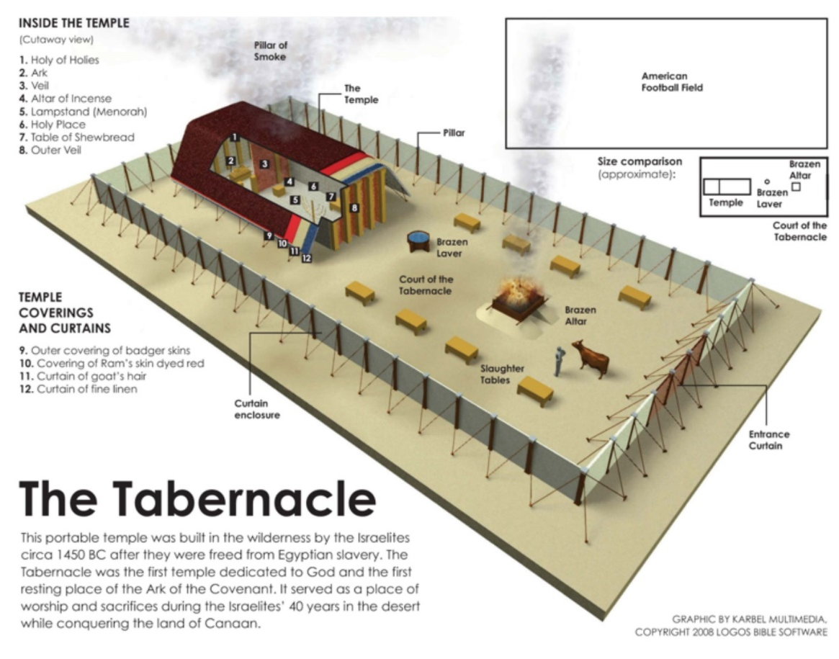
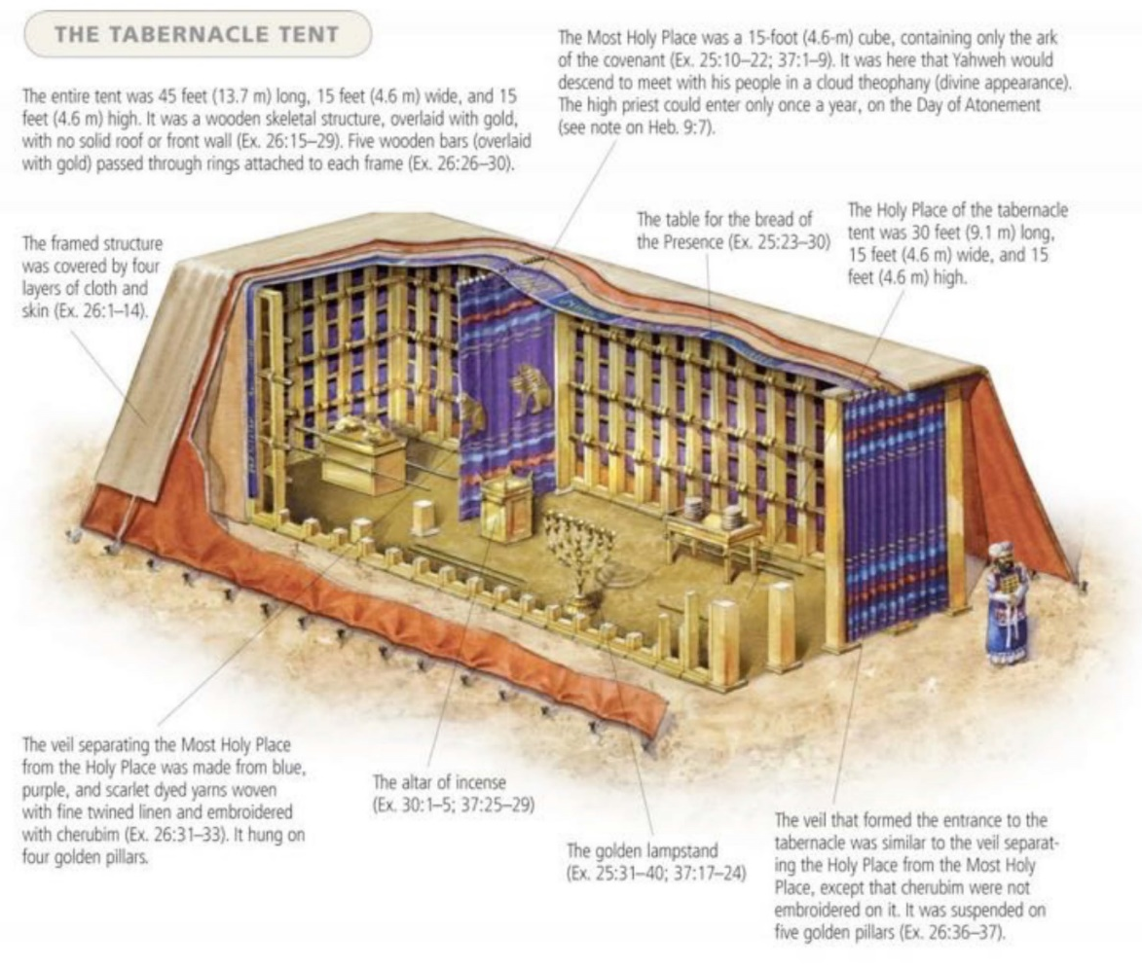

CHAPTERS 32-34: INTERRUPTION AND CRISIS
"When the Lord finished speaking to Moses on Mount Sinai, he gave him the two tablets of the covenant law, the tablets of stone inscribed by the finger of God." 31:18
At the same time, the people in the camp have taken the gold they have collected, which was supposed to be used to decorate the tent of the meeting, and made themselves a golden calf. The point of going out of Egypt was for the people to worship God (celebrate Passover). Instead, they worship an idol. In a way, it is a Fall once more after a new start in chapter 12. It goes so badly that God wants to wipe out the entire people. God warns them that judgment will come if they do not repent. Moses makes atonement for the people and averts judgment.
Moses makes himself a tent of his own:
"Moses used to take the tent and pitch it a good distance outside the camp. He called it the Tabernacle. All who wanted counsel from the Lord went out to this tent outside the camp." 33:7
Between chapter 19 (when God appears on the mountain) and chapter 40 (when they finish building the tent), ten months pass. It's a bit of a crisis. Did they ruin everything? What will God decide?
The author picks up on something that has been said before to form a framework around the interruption in chapters 32-34. In 35:1-2, it says about the Sabbath:
"Moses assembled the whole Israelite community and said to them, “These are the things the Lord has commanded you to do: For six days, work is to be done, but the seventh day shall be your holy day, a day of sabbath rest to the Lord. Whoever does any work on it is to be put to death." 35:1-2
This is a repetition of the last words in chapter 31 before the story of the golden calf (31:14-15). Now the crisis is forgotten, and we continue where we left off in chapter 31.

CAN GOD REPENT? (32:14)
"Then the Lord relented and did not bring on his people the disaster he had threatened." 32:14
"And the Lord repented of the evil which He thought to do unto His people." 32:14 KJ21
1. God is not a human, one who regrets. (Numbers 23:19; 1 Sam 15:11, 29)
"God is not human, that he should lie, not a human being, that he should change his mind. Does he speak and then not act? Does he promise and not fulfill?" Numbers 23:19
In this context, God will not change His mind about Israel. Balaam was hired by the Moabite king Balak to curse Israel, but God's word to Balaam and Balak is that God is not going to change his mind from blessing Israel to cursing them.
"I regret that I have made Saul king, because he has turned away from me and has not carried out my instructions.” Samuel was angry, and he cried out to the Lord all that night." 1 Sam 15:11
"He who is the Glory of Israel does not lie or change his mind; for he is not a human being, that he should change his mind." 1 Sam 15:29
The same Hebrew word (Strong's 5162) is also used in 1 Sam 15:11 and 35 about how the Lord repented/regretted that he had made Saul king. It can mean “to sigh, take deep breaths, to be sorry, to pity”. There are nuances in this word, and therefore the New Heart English Bible has "grieved" in these verses, and in Judg 2:18 the same word is translated as "moved to pity" in ESV. Thus, 1 Sam 15:11 and 35 need not mean that God repented in the sense that he realized that he had made a mistake. It is more likely a description of God's emotional reaction.
Here Saul tries to make God change his mind and not reject him as king, but God has made up his mind. He does not change his mind, as a human might have done.
The same Hebrew word is also used in vv. 11 and 35 about how God regretted that he had made Saul king. The word can thus describe:
a) an emotional reaction of grief or pity (e.g., Judges 2:18)
"Whenever the Lord raised up a judge for them, he was with the judge and saved them out of the hands of their enemies as long as the judge lived; for the Lord relented because of their groaning under those who oppressed and afflicted them." Judges 2:18
b) and it may mean changing one's mind
God did not suddenly realize that he had thought wrong, but he was sad because of the situation with Saul.
2. What about the promise to Judah in Genesis 49:10?
"The scepter will not depart from Judah, nor the ruler’s staff from between his feet, until he to whom it belongs shall come and the obedience of the nations shall be his." Gen 49:10
God could have started over again with Moses and still fulfilled the promise to Abraham that a great nation would come from him since Moses was also a descendant of Abraham. But the messianic promise to Judah could then not be fulfilled, since Moses was not a descendant of Judah but of Levi. So how "serious" was God when he threatened to destroy the people in Exodus 32? Is he really saying that this is what they deserve, without having planned to carry it out?
3. God often changes plans based on people's responses (Jer 18:7-10, Jonah 3:10).
"If at any time I announce that a nation or kingdom is to be uprooted, torn down and destroyed, and if that nation I warned repents of its evil, then I will relent and not inflict on it the disaster I had planned. And if at another time I announce that a nation or kingdom is to be built up and planted, and if it does evil in my sight and does not obey me, then I will reconsider the good I had intended to do for it." Jer 18:7-10
"When God saw what they did and how they turned from their evil ways, he relented and did not bring on them the destruction he had threatened." Jonah 3:10
This depends on the people's response to the threat of judgment. The prophet's task was not only to tell the people about the judgment before it happened as if to impress upon them that God knew the future. God wanted to warn them of the judgment to make them repent, precisely to avoid the judgment. God would change his plans if the people changed their plans.
God "changes his mind", and Jonah gets angry and says that it was exactly what he knew was going to happen: "He prayed to the Lord, “Isn’t this what I said, Lord, when I was still at home? That is what I tried to forestall by fleeing to Tarshish. I knew that you are a gracious and compassionate God, slow to anger and abounding in love, a God who relents from sending calamity." (Jon 4:2)
Jonah confirms that God "changes his mind" because he is good - not because he is influenced by others.
4. “Perhaps I can make atonement for your sin.” (v. 30, Numbers 16:41-50)
“The next day Moses said to the people, “You have committed a great sin. But now I will go up to the Lord; perhaps I can make atonement for your sin.” 32:30
“The plague had already started among the people, but Aaron offered the incense and made atonement for them. He stood between the living and the dead, and the plague stopped.” Numbers 16,47b-48
Moses intercedes for the people and manages to avert complete destruction, which would have been the penalty for breaking the covenant and sinning. Nevertheless, there was a partial judgment in 32:28 “that day about three thousand of the people died”, and the prayer of Moses in 32:11-13 that God should relent and turn from his fierce anger was not enough. Atonement for sin against a holy God was still needed.
Moses offers his own life as atonement for the people, but God rejects this (vv. 32-34). Not because it is a bad idea (NT), but because Moses was not sinless and his sacrifice was insufficient. And it was not yet time for this. The bottom line: atonement is always necessary, and this seems to happen in v. 35:
"And the Lord struck the people with a plague because of what they did with the calf Aaron had made." (Exodus 32:35)
Exodus 32 describes the wrath of a holy God against sin, and atonement is necessary to avert it. God does not change his mind because he is convinced by Moses, but the consequences change because Moses intercedes for the people, repents on their behalf, and makes a form of atonement.
God is still holy, sin is still sin, and atonement is still necessary to avert judgment. God is still the same. So why doesn't he act this way anymore?
Because Jesus has made atonement for us once and for all with an eternal sacrifice. Without Jesus, the same thing would have happened again. But Jesus always lives and intercedes for us. (Heb 7:25). What Moses did in Exodus 32, Jesus does all the time.
"But if anybody does sin, we have an advocate with the Father—Jesus Christ, the Righteous One. He is the atoning sacrifice for our sins, and not only for ours but also for the sins of the whole world." (1 John 2:1-2)

“HOLY TO THE LORD”
“Make a plate of pure gold and engrave on it as on a seal: holy to the Lord." 28:36
The headdress of the high priest was to be adorned in front with a plate of pure gold bearing the inscription "holy to the Lord". The verses from Zechariah and John below show how this pointed to Jesus. Zechariah ends with everything becoming holy and with a reference to the Feast of Tabernacles, which then appears in John 7.
"On that day living water will flow out from Jerusalem, half of it east to the Dead Sea and half of it west to the Mediterranean Sea, in summer and in winter." Zech 14:8
"On that day holy to the Lord will be inscribed on the bells of the horses, and the cooking pots in the Lord’s house will be like the sacred bowls in front of the altar." Zech 4:20
"On the last and greatest day of the festival, Jesus stood and said in a loud voice, “Let anyone who is thirsty come to me and drink. Whoever believes in me, as Scripture has said, rivers of living water will flow from within them." John 7:37-38

THE MEETING TENT AND CREATION SYMBOLISM
There were cherubim above the cover of the ark (25:22; 26:1). Cherubim also guarded Eden (Genesis 3:24).
"There, above the cover between the two cherubim that are over the ark of the covenant law, I will meet with you and give you all my commands for the Israelites." Ex 25:22
"Make the tabernacle with ten curtains of finely twisted linen and blue, purple and scarlet yarn, with cherubim woven into them by a skilled worker." Ex 26:1
"After he drove the man out, he placed on the east side of the Garden of Eden cherubim and a flaming sword flashing back and forth to guard the way to the tree of life." Genesis 3:24
Both the tent of meeting and the Garden of Eden had an entrance from the east (26:22, Genesis 3:24).
In these chapters, the phrase "The Lord said to Moses" is repeated 7 times. This corresponds to the number of days in creation. The 7th time God speaks to Moses, the theme is to rest on the Sabbath, as God did on the 7th day in the creation account:
"... on the seventh day he rested and was refreshed." (Ex 31:17 ends the instructions)
"... on the seventh day he rested from all his work.” (Genesis 2:2)
The consecration of the priests lasted 7 days (29:35).
"Do for Aaron and his sons everything I have commanded you, taking seven days to ordain them." 29:35
“Spirit of God” (31:3) is only mentioned in Genesis 1:2 before it is mentioned here about Bezalel, who is helping to construct the tent of meeting:
"and I have filled him with the Spirit of God, with wisdom, with understanding, with knowledge and with all kinds of skills—" 31:3

Genesis 1-2 | Exodus 39-40
"Then the heavens and the earth were finished" (Genesis 2:1) | "Thus all the work on the dwelling, the tabernacle, was completed." (Exodus 39:32)
"God blessed them" (Genesis 1:22, 28) | "Moses blessed them [the Israelites]" (Exodus 39:43)
"God saw all that he had made, and behold, it was very good!" (Genesis 1:31) | "Moses looked at all that had been done, and behold, they had done as the Lord had commanded." (Exodus 39:43)
"On the seventh day God finished the work he had done" (Genesis 2:2) | "Thus Moses finished the work" (Exodus 40:33)

The point of all these links back to creation seems to be that God is creating something new with this tabernacle. He is creating new people who will be used to fix what was broken with Adam. God makes it possible for them to have fellowship with Him again. It is more than a tent; it is God who comes down to earth.

40:34-38
"Then the cloud covered the tent of meeting, and the glory of the Lord filled the tabernacle. Moses could not enter the tent of meeting because the cloud had settled on it, and the glory of the Lord filled the tabernacle. In all the travels of the Israelites, whenever the cloud lifted from above the tabernacle, they would set out; but if the cloud did not lift, they did not set out—until the day it lifted. So the cloud of the Lord was over the tabernacle by day, and fire was in the cloud by night, in the sight of all the Israelites during all their travels." 40:34-38
Moses could not enter the tent after God moved in because God is holy. Leviticus begins with God inviting Moses and instructing him on how they can enter the tabernacle and have fellowship with God. Maybe this happens on the same day? The whole book of Leviticus is about that, how they should sacrifice, etc. God is both holy and near.

GOD'S GLORY AND DWELLING
- "Then the cloud covered the tent of meeting, and the glory of the Lord filled the tabernacle." Exodus 40:34
- "When the priests withdrew from the Holy Place, the cloud filled the temple of the Lord. And the priests could not perform their service because of the cloud, for the glory of the Lord filled his temple." 1 Kings 8:10-11
- "The glory of this present house will be greater than the glory of the former house,’ says the Lord Almighty. ‘And in this place I will grant peace,’ declares the Lord Almighty." Hag 2:9
- "The Word became flesh and made his dwelling among us. We have seen his glory, the glory of the one and only Son, who came from the Father, full of grace and truth." John 1:14
- "For God was pleased to have all his fullness dwell in him" Col 1:19
- "Don’t you know that you yourselves are God’s temple and that God’s Spirit dwells in your midst? If anyone destroys God’s temple, God will destroy that person; for God’s temple is sacred, and you together are that temple." 1 Corinthians 3:16-17
- “Do you not know that your bodies are temples of the Holy Spirit, who is in you, whom you have received from God?” 1 Corinthians 6:19a
- "I did not see any temple in the city, for the Lord God, the Almighty, and the Lamb is its temple. And the city needs no light from sun or moon, for the glory of God shines upon it, and the Lamb is its light." Revelation 21:22-23
- “As obedient children, do not conform to the evil desires you had when you lived in ignorance. But just as he who called you is holy, so be holy in all you do; for it is written: “Be holy, because I am holy.” 1 Peter 1:14-16

WHAT DOES THE BOOK OF EXODUS MEAN TO US?
- The holy God saved Israel from slavery, made them his people, revealed his character and will in the law, and desired to dwell among them in the tabernacle. The aim of this was that the same holy God would save you from the slavery of sin, make you his child, reveal himself and his will in Jesus, and live in you. What is your response to this in light of Exodus?
- What have you learned about God's character in this book?
- How are we similar to the Israelites in Exodus, and how are we different?

